Final Project (15%)

Learning outcomes

Upon successful completion of this project, you will have demonstrated the abilities to:

1. Convert tables into 3NF and infer the associated ERD
2. Implement the relational database model by creating tables and constraints on attributes
3. Enter data into the database
4. Query the database to retrieve information.

Group Work

Please work in **groups** to complete this project. This project is worth 15% of the total course grade and will be evaluated through your written submission. Each day being late will result in 10% penalty.

Submission

Please submit the following files through Blackboard. Only one person must submit for the team.

* Project SQL file: Project2_grpGroupNumber.SQL
* Project document: Project2_grpGroupNumber.docx

Group work

1. Add this declaration on the top of your file.

We, ------------(mention your names), declare that the attached assignment is our own work in accordance with the Seneca Academic Policy. No part of this assignment has been copied manually or electronically from any other source (including web sites) **or distributed to other students.**

1. Specify what each member has done towards the completion of this work:

|  |  |  |
| --- | --- | --- |
|  | Name | Task(s) |
| 1 |  |  |
| 2 |  |  |
| 3 |  |  |

Project overview

The CheapFare airline reservation company is a flight booking company of domestic and international airline tickets. The company wants to use a relational database for its operations. The manager has decided to refer to exemplar of bookings that are usually issued following a flight reservation by customers.

During the interview with the airline reservation company manager, the following information has been obtained:

1. Each booking may correspond to a one-way trip or a round-trip with several flights booked to lead to destination.
2. A flight is identified with a flight_num. A flight num(e.g. AF393) determines the airline the flight belongs to (e.g. AF), and might be operated by a partnering airline (operatedBy is an airline_code).
3. Each flight is always associated with an aircraft determined with aircraft_code and description.
4. Flights determined with a flight_num always operate from same departure airport to the same arrival airport. Departure dates and time and arrival dates and time may vary.
5. A booking may generate several etickets, one per passenger. For example, booking_id 56753365  for a mom and two kids generates 3 different etickets.
6. Each ticket is identified with a eticket_num and it belongs to one traveler. The database should also save the traveler meal preference (optional), the ticket price and the ticket tax fees. .
7. A traveler is identified with a traveler id and has last and first name and gender.



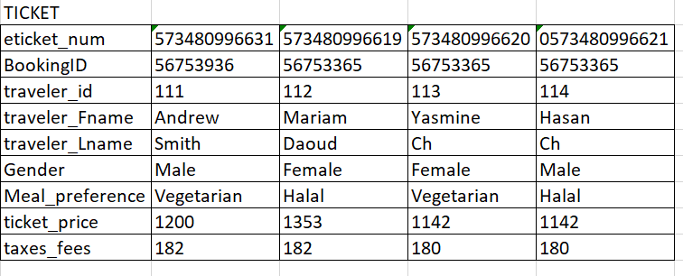

Part I. Database Normalization and Entity Relationship Model (30%)

* For each of the given tables, convert to 3NF, *showing all steps* (from 1NF to 3NF). Use the arrow notation. Do NOT include derived attributes. Consider the composite key (bookingID, flight_num) as PK in the bookingRecord table.
* Combine the tables obtained at the end of the normalization process into one logical design. Draw the *ERD* using Microsoft Visio. Note that your design must not have any many-to-many relationships or multi-valued attributes. PK and FK must be clearly stated. Strong and weak relationships must be labelled correctly. Export the ERD to .jpg and insert in your project document file.

Part II. Database IMPLEMENTATION (20%)

In your SQL file, write the SQL statements to:

1. Create a database named DBS211_Ass2_YourGroupNo.
2. Create the tables of your relational database model. Specify the PK, FK, and other necessary constraints.
3. Show a screenshot of the object explorer displaying the table’s columns, keys and constraints. You can include many screenshots.
4. Enter the data from the samples shown in the given tables. Include all insert quries in you SQL file.

Part III. Data Manipulation (20%)

For the following questions, include

1. The **SQL command** (both in the SQL file and the document file)
2. The **output** in text format,
3. **The number of rows** affected.
4. List the airline, aircraft and airport details for flight number AF393. Display the flight number, airline code and name, aircraft code and description, departure airport code and name and arrival airport code and name.
5. List the flight details for bookingId 56753365. Display booking id, booking date, the flight number (there should show several flights records for this booking), departure airport code, departure date and time, arrival airport code, arrival date and time. Order the rows by departure date and time.
6. List all passengers for bookingID 56753365. Display the bookingID, eticket number, traveler first and last name. This should show 3 passengers with 3 different etickets.
7. Calculate the total fees for bookingID 56753365. This should be the sum of ticket price and tax fees for the three tickets associated with this booking. (Hint: this does not need a group by). Use a where clause to select only the tickets for that booking and use the sum() function.
8. Create a view named as Book_ticket. In the view show the list of all bookings and the number of tickets associated with each.